How To – Order Supplies from Sam’s Club, Walmart, and Amazon
Step 1. For Walmart of Sam’s Club Purchases- Login to Yazing.com
When logging in to Sam’s Club and Walmart, you need to login to Yazing first at: https://yazing.com/
For Amazon, you can go directly to amazon.com to login.
On the Yazing website you can either click the Walmart icon to go to Walmart or search for Walmart in the search bar at the top if the icon is not shown as below.
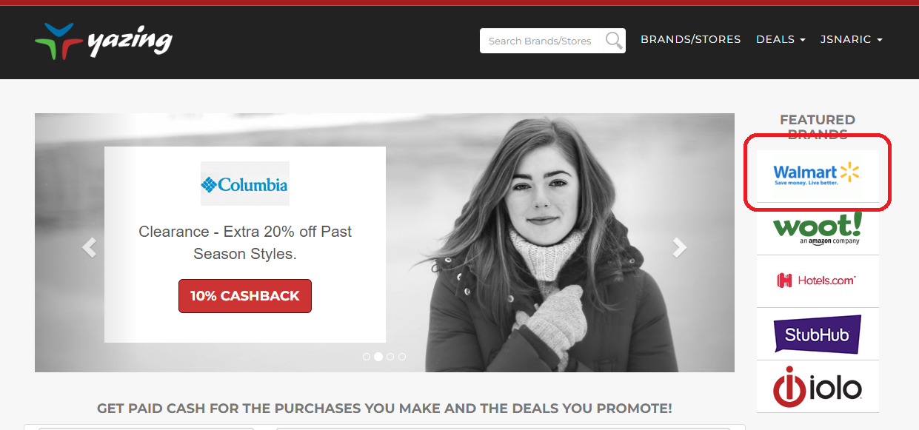
Click any of the green buttons to be routed to Walmart’s website.
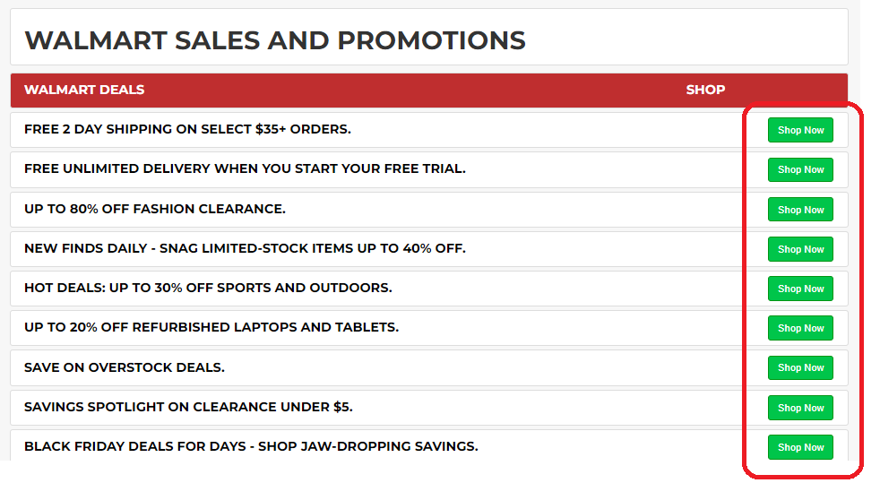

For Sam’s Club, use the search box and search Sam’s Club.
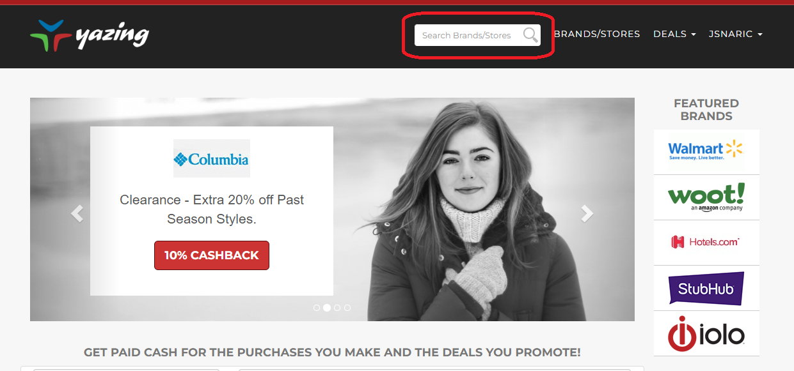

Click “Shop to Earn”.
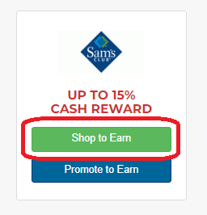

Then click on any of the green buttons.
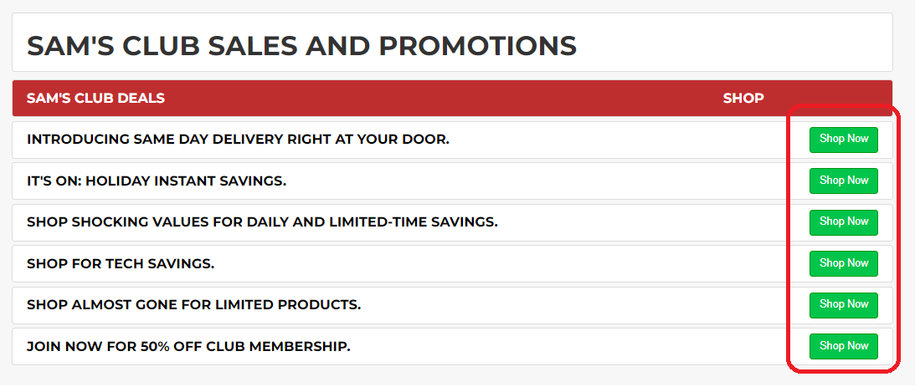
To login to Amazon, go directly to https://amazon.com.
Step 2. Look for the best deal!
Search for the product that you want to order on all three websites (Amazon, Sam’s Club, and Walmart). Compare prices and look for the lowest cost per unit.
Example: AA Batteries
SAM’S CLUB WALMART AMAZON
$0.45 per unit $0.62 per unit $0.34 per unit
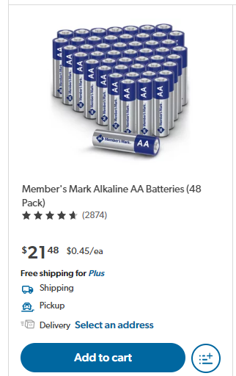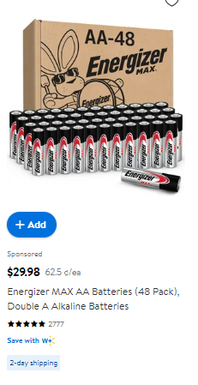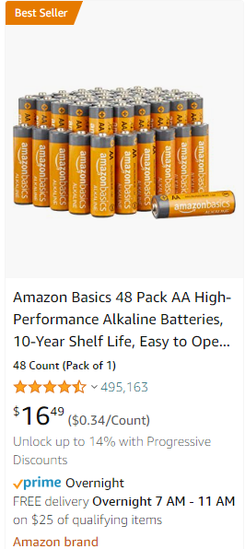

In the example above, the lowest price that we can get the AA Batteries is from Amazon ($0.34 per unit).
Continue looking for the lowest price per unit for the other office supplies that you will order.
After comparing the prices, add to cart the items that you want to order.
Step 3. Adding items to the Shopping Cart and Completing the Purchase

3A. Adding to Cart and Checking out (Amazon)
Once you have identified the product you need to purchase, Click “Buy new” option and enter the quantity that you want to order. Then click “Add to Cart” button.
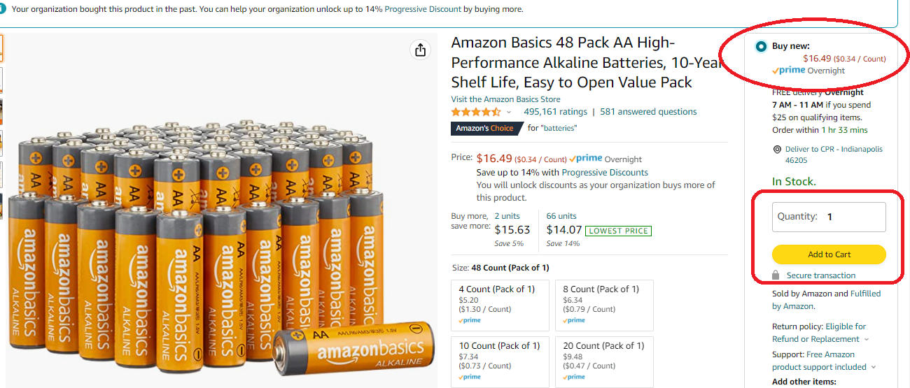
After all items that you need to purchase are in the cart, go to check out. You can click the “Proceed to check out” button or you can click the cart icon on the upper right corner of the website.
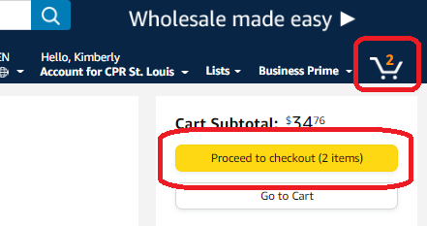
On the CHECKOUT page in the PO number box, put the city that you are ordering the items for and the items that you ordered. Click “Continue” once done.
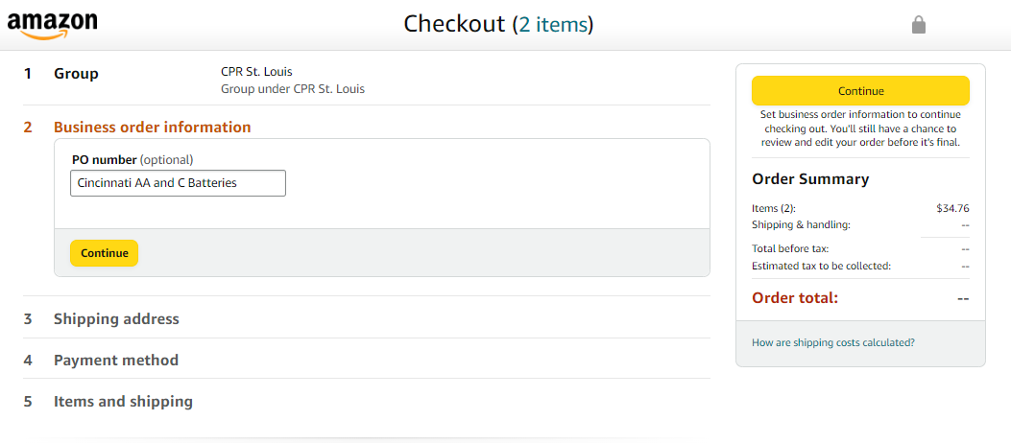
Choose the shipping address. Training sites addresses were pre-saved.
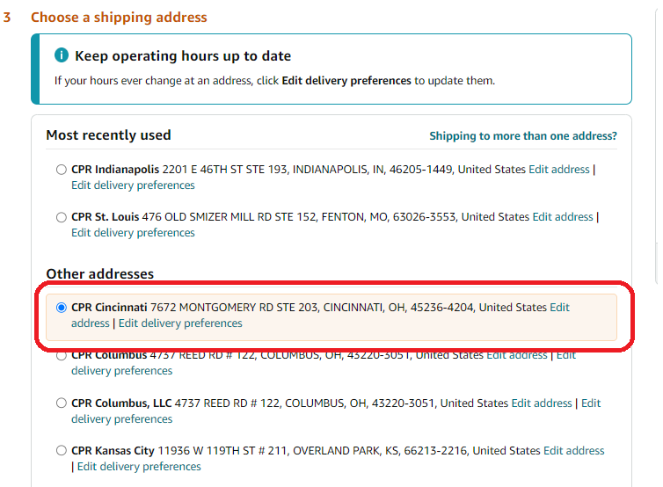
Click the “Use this address” button at the bottom after clicking the address of the city that you are ordering the items for.
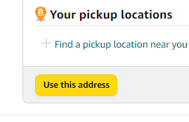
For the payment method, click the pre-saved company card. Visa ending in 2981. Then click “Use this payment method” once done.
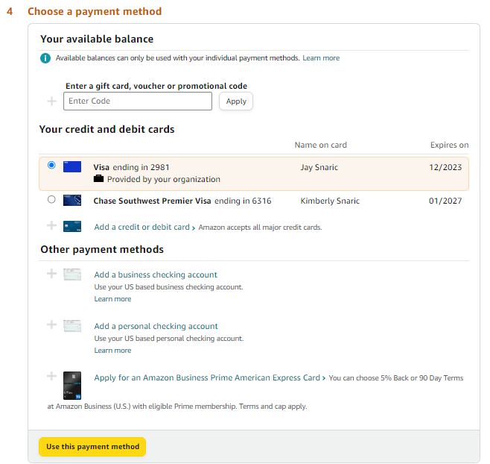
Review your order and click “Place Order” button once you are all set.
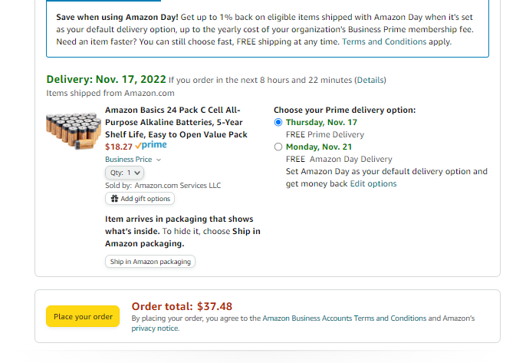
After placing your order, click the “Review or edit your recent orders” link.
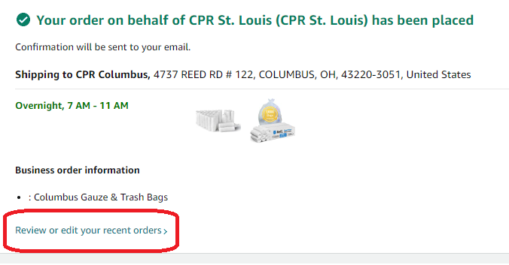
You will be routed to Your Orders page. Click “Printable Order Summary”.
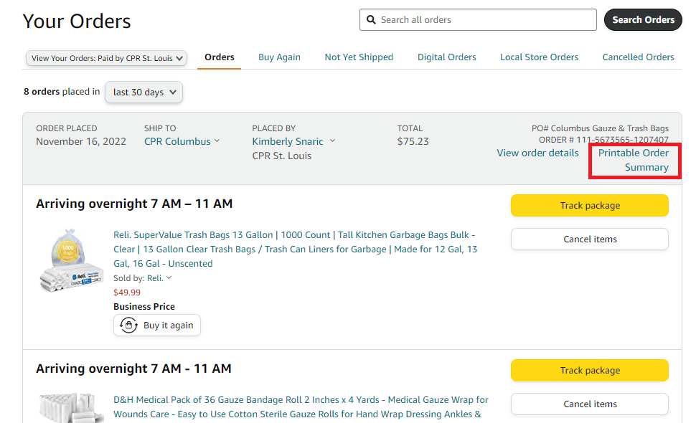
Click the download icon to download the order receipt.
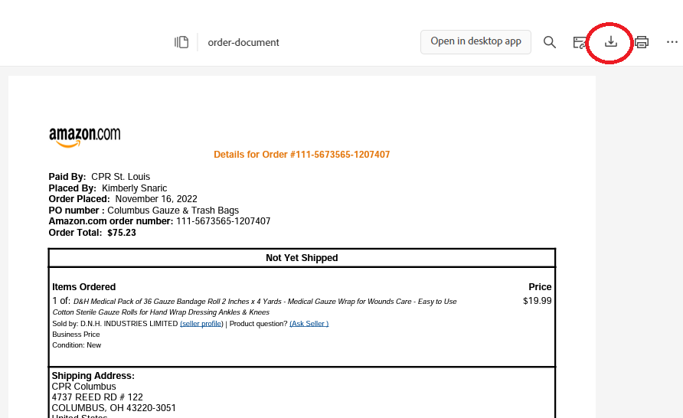
Go to your downloads folder on your computer and rename the file.
Date – Supplier – Items Ordered – City – Total Amount of the order
Example:
11-16-2022 Amazon Rolled Gauze and Trash Bags Columbus $75.23

3B. Adding to Cart and Checking out (Sam’s Club)
Click on the product that you want to order. Make sure you click the shipping option. Finalize the quantity that you want to order. Click “Add to cart” once done.
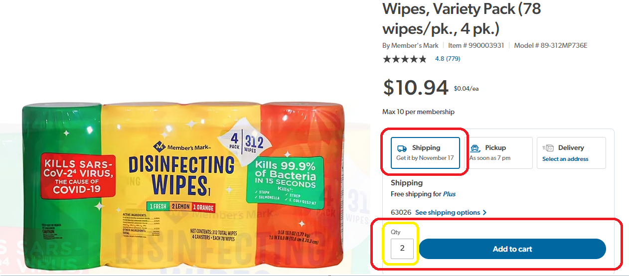
Click “View cart” if this is the only item that you are ordering. If you want to add more items to your cart, click “Continue shopping”.
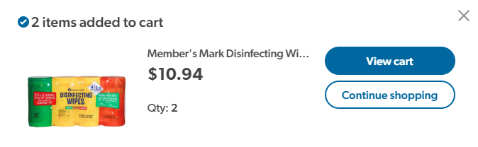
Review the items on your cart. Once everything looks good, click “Begin checkout” button.
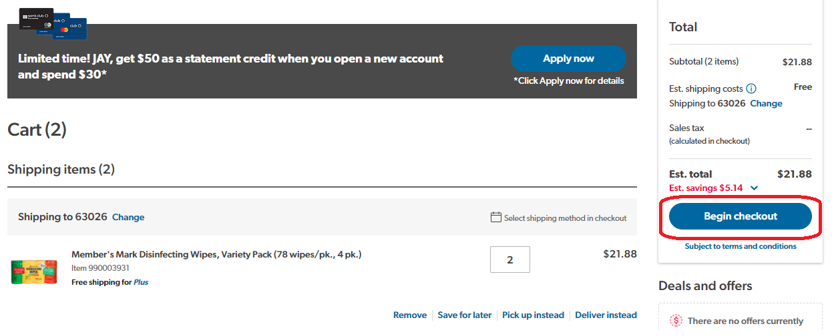
To change the shipping address, click the “change” button.
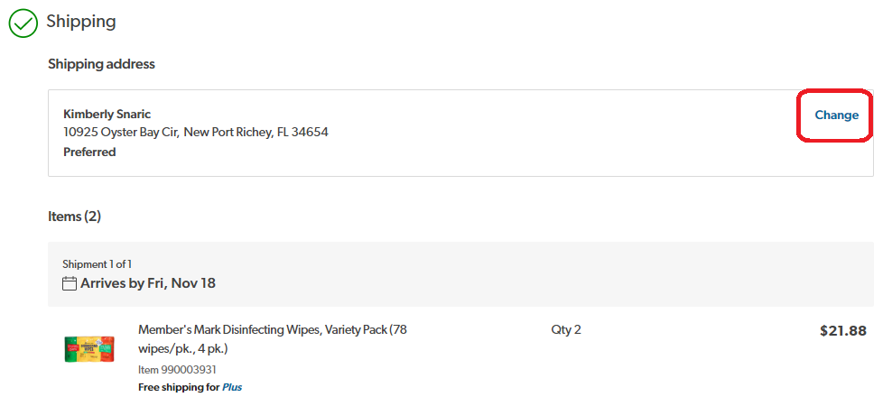
There are pre-saved shipping addresses. Look for the address of the training site that you are ordering the item/s for. Click “Show more” to see more addresses.
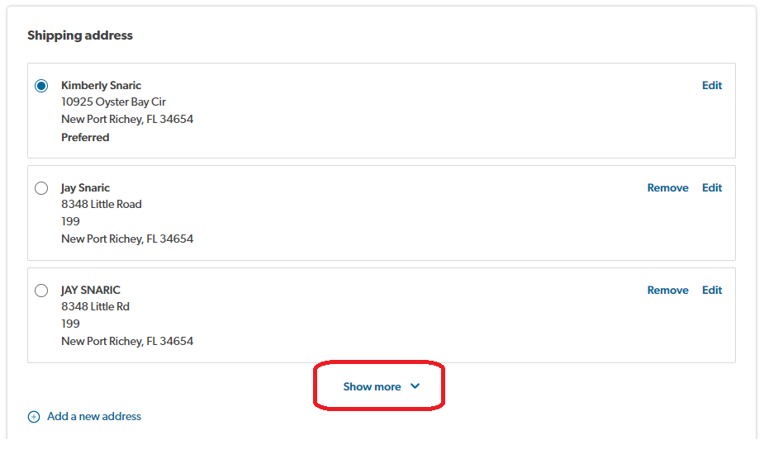
If the address is not saved yet, click on “Add a new address”
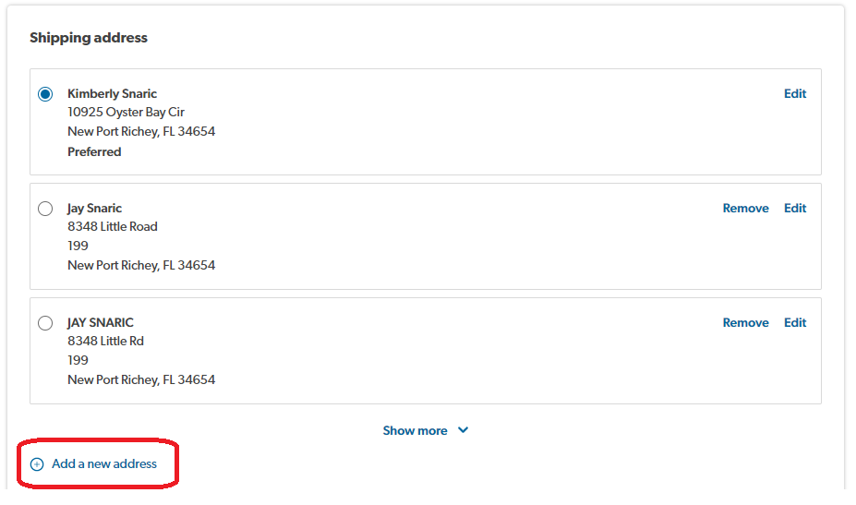

Click the “Business” option and fill out the information needed. You can put your direct RC number for the phone number. Click the “Save” button once done.
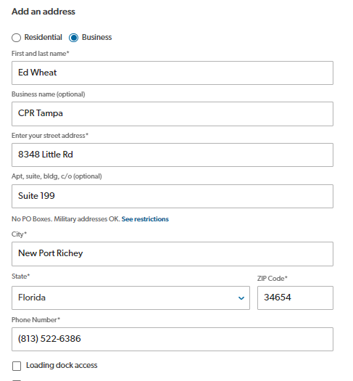
If you get an error message that says “We can’t verify the address you entered. Please check that it’s correct.” Double check the address and if it is correct, click on “Use this address” button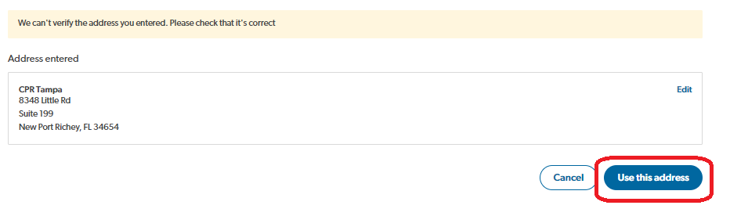
The payment method is already saved. You just have to put the CVV.
Review everything to ensure that everything is correct. If you are all set, click on the “Place order” button.
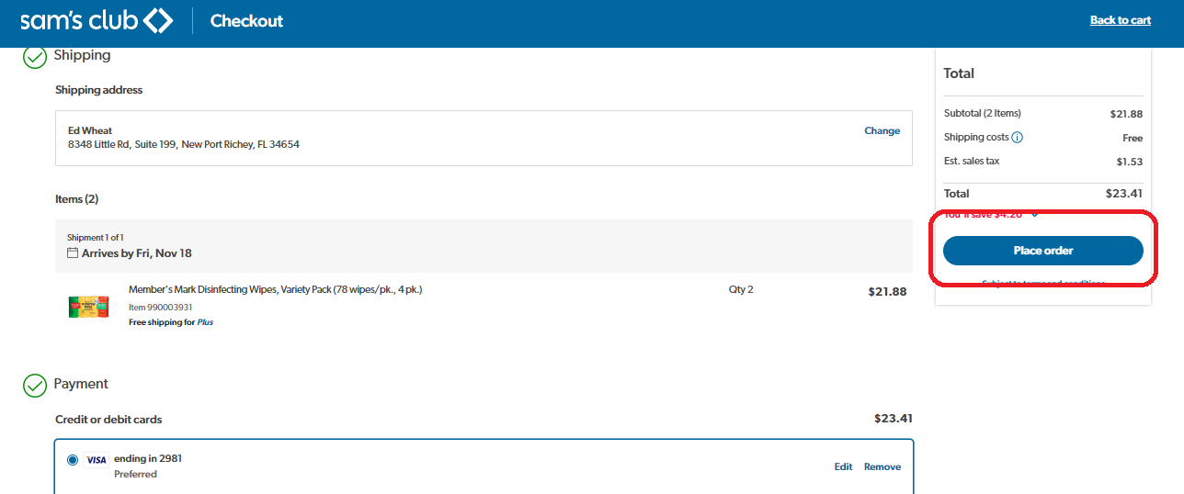

Click “Review your order”.
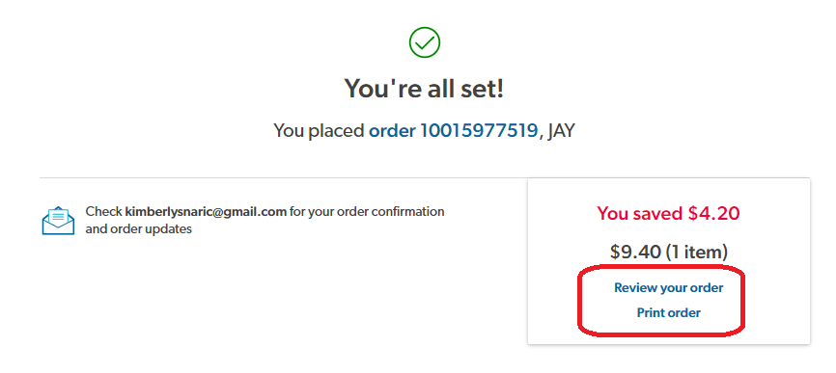

You will be routed to the Order Details page. Click “Print Receipt” link.
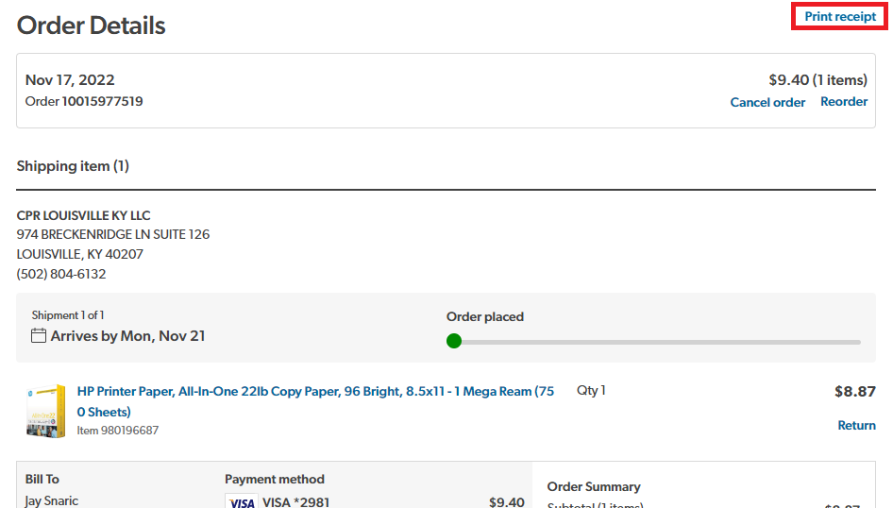
Make sure the destination says, “Save as PDF”. Click the save button below.
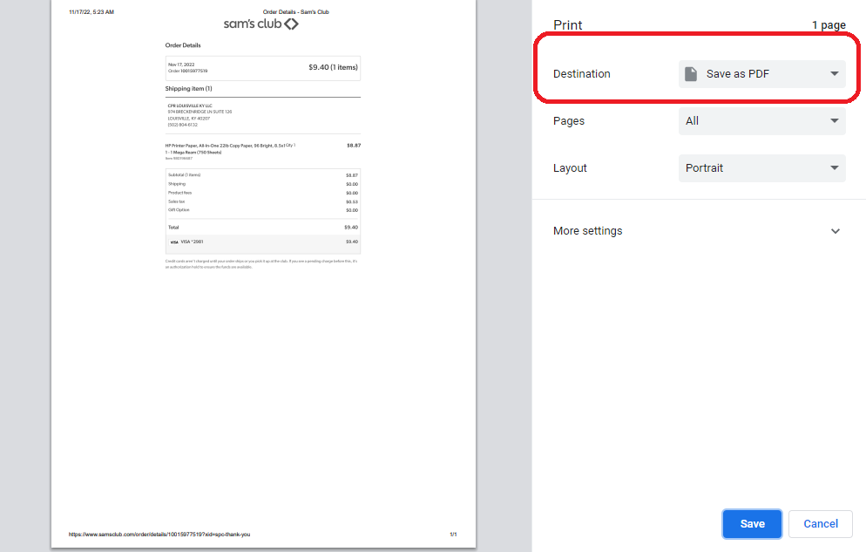
File name should be Date – Supplier – Items Ordered – City – Total Order Amount
Example:
11-16-2022 Sam’s Club Copy Paper 750 sheets Louisville $9.40
3C. Adding to Cart and Checking Out (Walmart)
Step 2C. Click on the product that you want to order and click “Add to cart”.
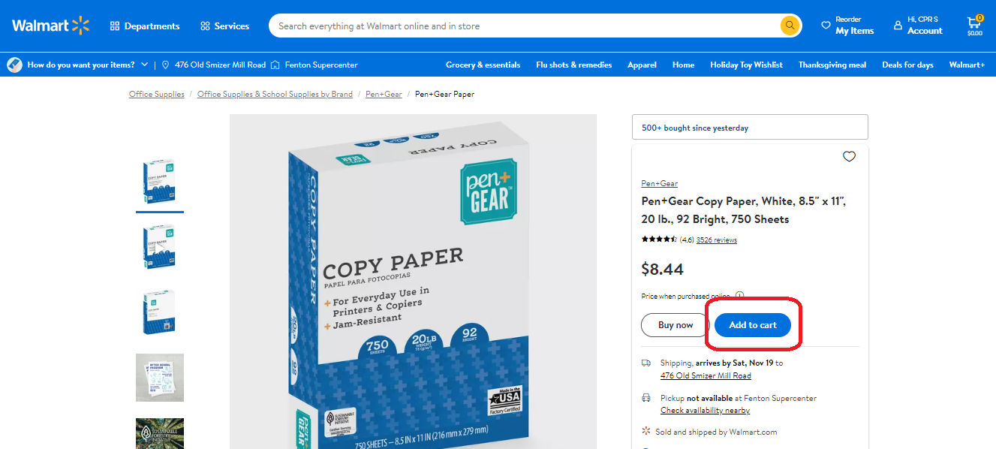
You can adjust the quantity by clicking the plus (+) or minus (-)
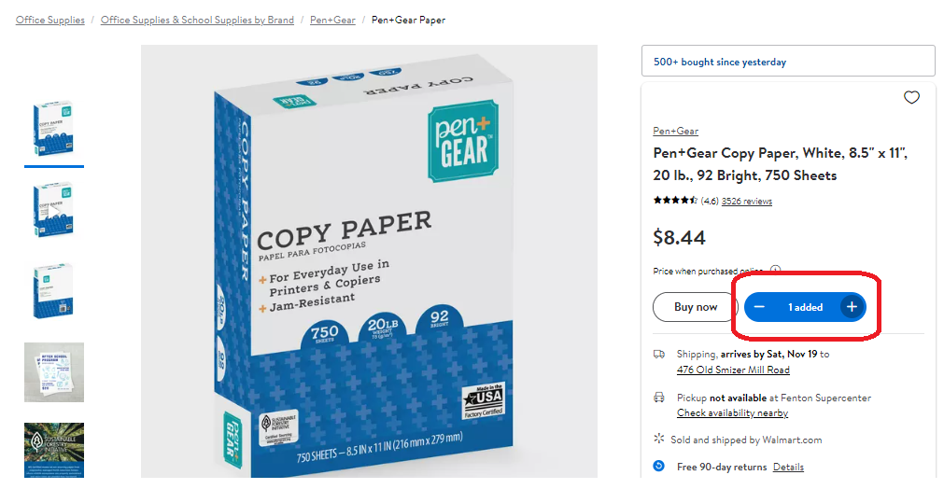
Click the cart icon on the upper right-hand corner of the page.
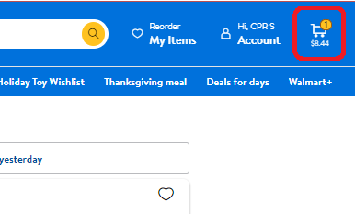

The shipping addresses for the training sites are already saved. Click “Edit” and choose the address of the training site that you are ordering the item/s for.
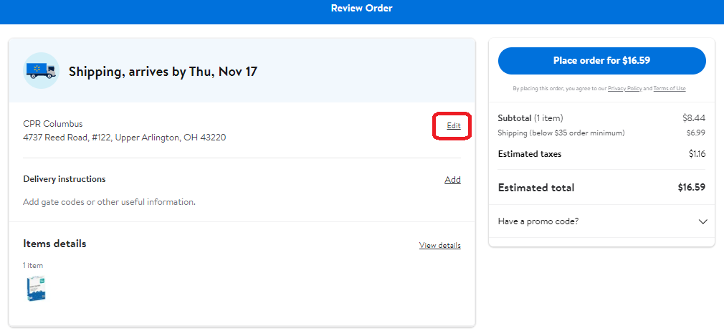
And click “save” after choosing the address.
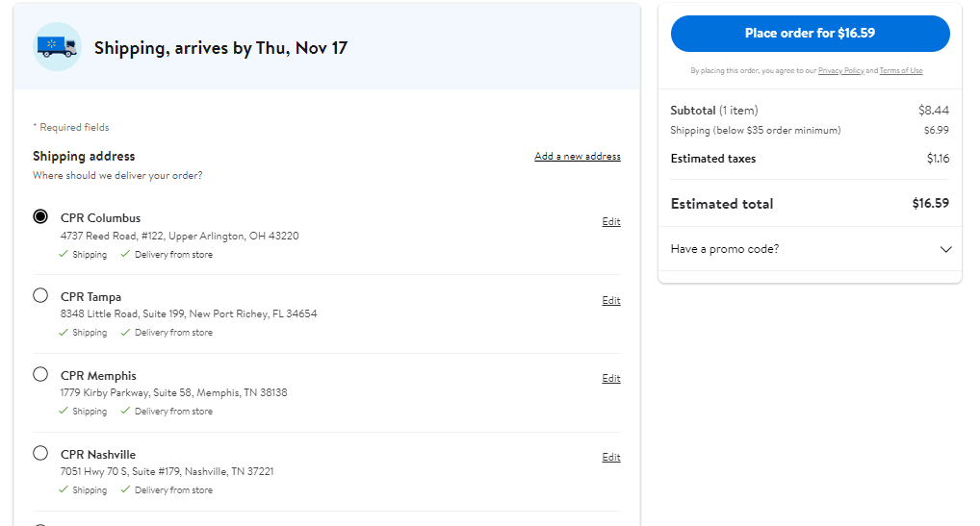

For the payment method, type the CVV only- the card information is already saved.

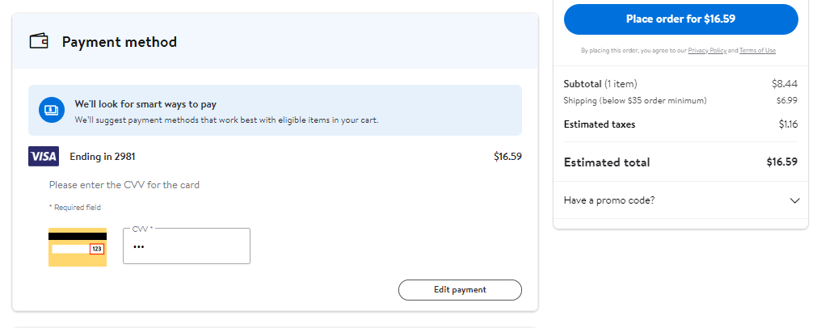

Review everything to make sure that it is correct. Once you are all set, click the “Place order” button.

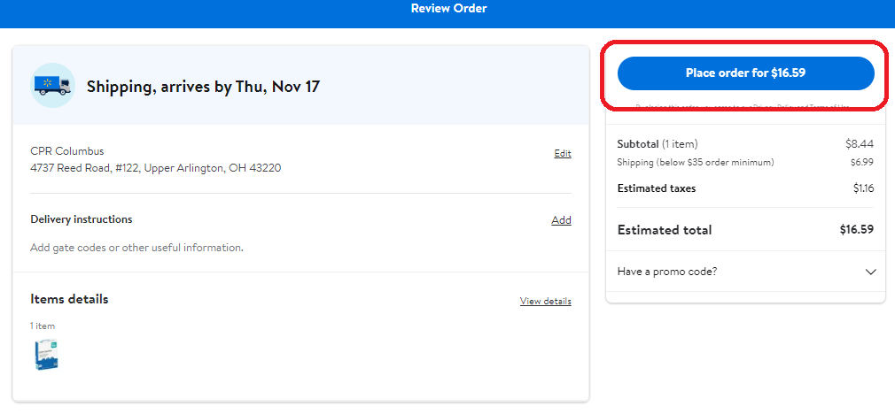

After the order is placed, click on “Account” tab and go to Purchase History.
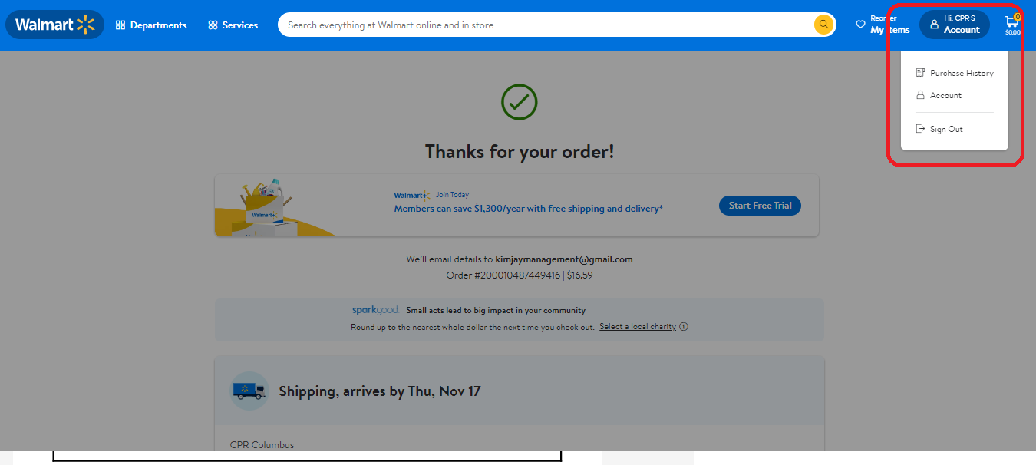
You will be routed to the Purchase History page. Locate your order and click “View details” tab.
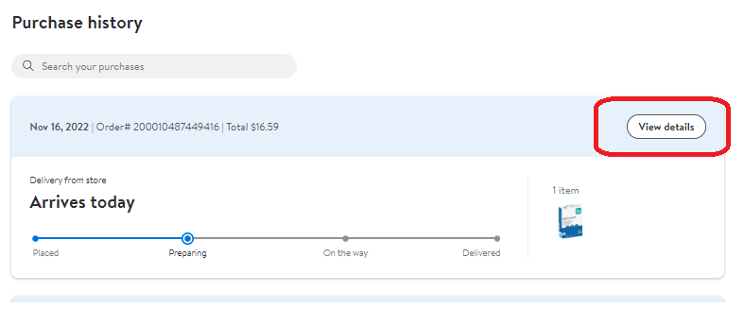
Click on the small “Print” link.
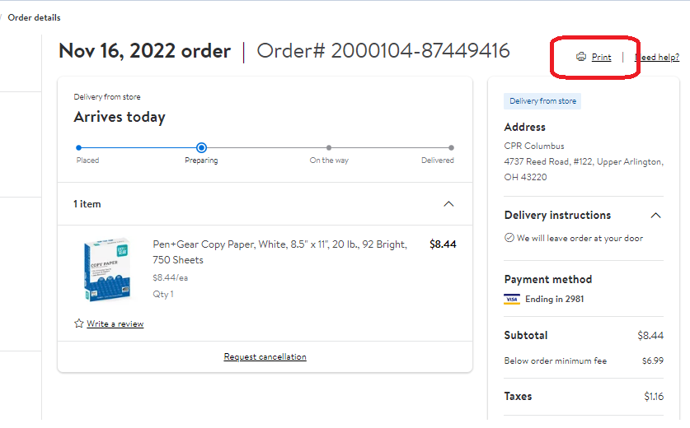

Make sure to choose the “Save as PDF” option in the destination. Click the save button below.
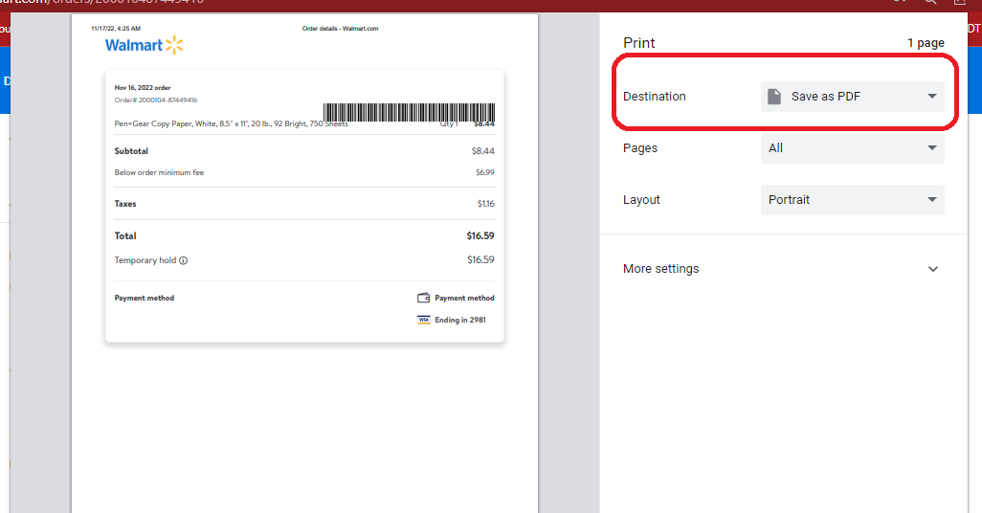
File name should be Date – Supplier – Items Ordered – City – Total Order Amount
Example:
11-16-2022 Walmart Copy Paper 750 sheets Columbus $16.59

Step 4. Documentation and Uploading the Receipts to Dropbox
After ordering the items, save and upload the order receipt to the city’s respective folders.
4A. Upload the receipts to Dropbox.
Go to DropBox > 1 - Receipts > Current Year Receipts
Locate the folder of the city that you are ordering the items for and then go to the current month. Upload the receipt(s).
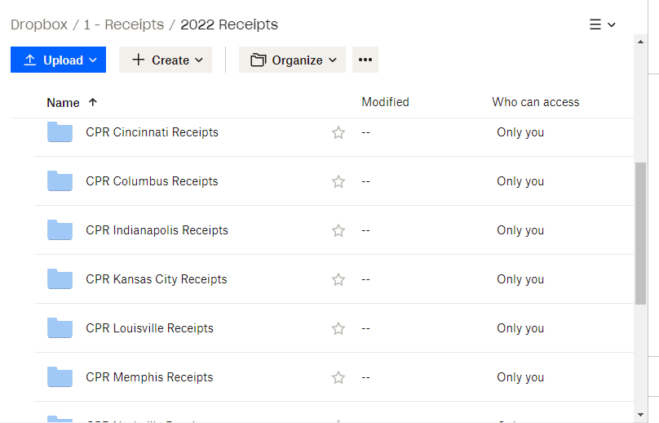
Refresh to ensure that it is saved.
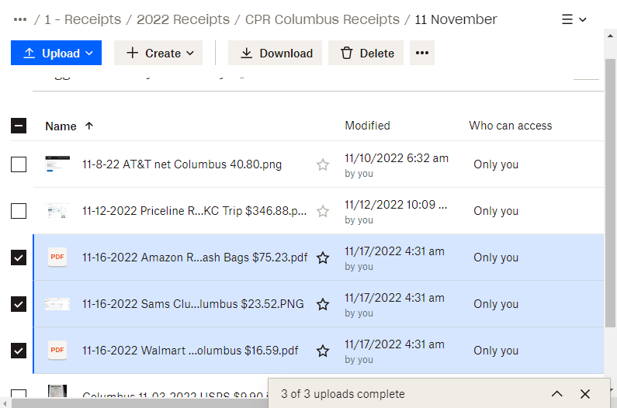
Step 4B Fill out the spreadsheet for Ordering Materials and Supplies in Dropbox
To open the spreadsheet, go to:
DropBox > 1 - Receipts > Current Year Receipts > Current Year Materials and Supplies Order Tracker
Fill out the information needed (date, your name, supplier, items ordered, etc.).
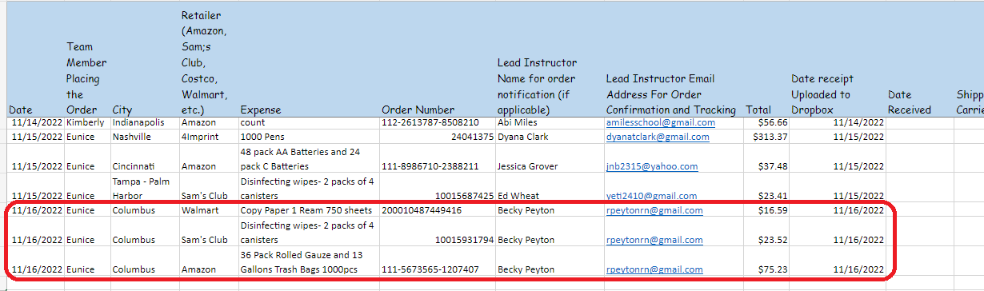

Step 4C. Notify the instructor their supply order has been ordered.
Send an email to the lead instructor and inform them about the items that were ordered for their respective city. Copy Dyana Clark in your email.
Example:
Hello (lead instructor name)!
Good day!
We’ve ordered (items ordered) for CPR (their respective city).
I will send the tracking information once available.
If you need anything, please don’t hesitate to let us know.
Have a great day!
(Your Name)

Step 4D. Send the tracking information for the order to the lead instructor.
After a day or two, you will be receiving an email with the tracking information for your order.
Send another email to the lead instructor once you received it. See email examples below:
SAM’S CLUB:
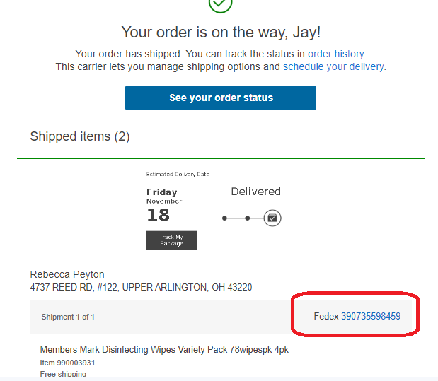
WALMART:
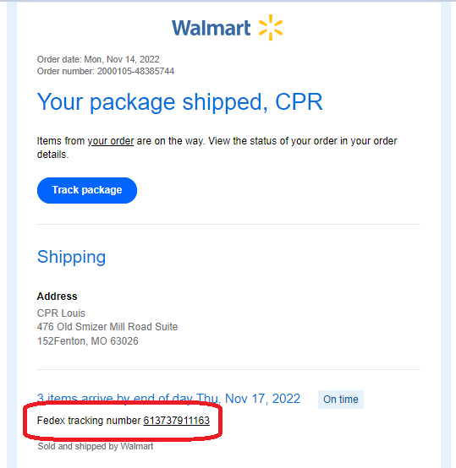
AMAZON: Click the “Track Package” button.
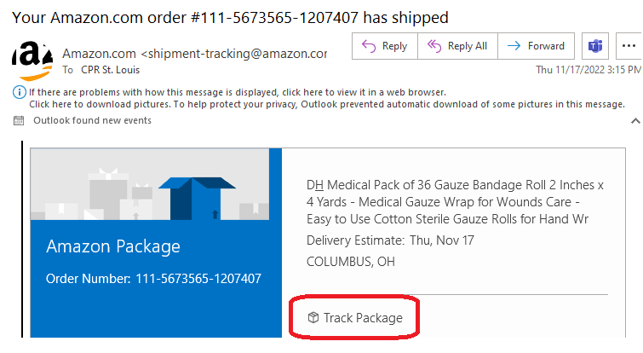
You will be routed to Amazon’s order detail page. You can also see the shipping progress by clicking “See all updates”.
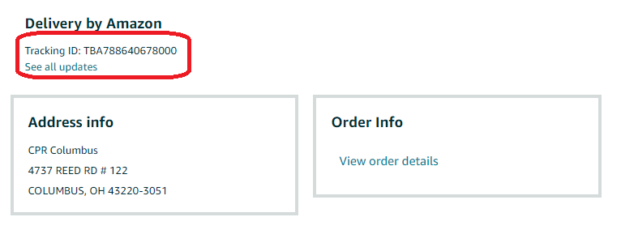

Send an email to the instructor using the template below.
Hello (Lead Instructor),
Good day!
We’ve ordered the following supplies below for CPR (City).
(list the items that you ordered)
Tracking number: (Add the tracking number here)
Shipped to: (Add the Shipping address here)
Please let us know once you’ve received it.
If you need anything, please don’t hesitate to reach out. Have a fantastic day!
(Your Name)
Once the instructor will notify us that they received the item(s) you ordered, do the following steps in How To- Processing Lead Instructor Received Inventory Emails and Reports.

