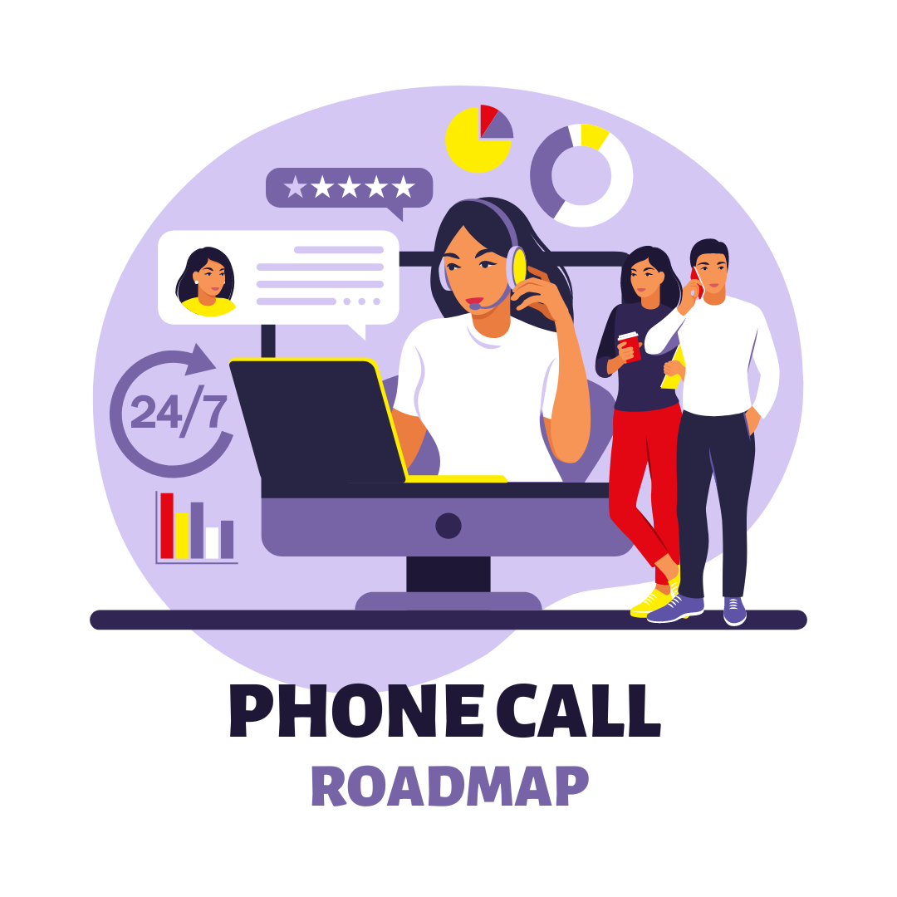
Class Registration
If the student is calling to register for a CPR Class, you have to determine which CPR Class she needs.
Questions that you can ask:
“Is this CPR for Healthcare or Non-healthcare?”
“If you don’t mind, what do you need this certification for?”
If you are still unsure, ask what’s her job/work.

If they need Heartsaver CPR and did not indicate that they need First Aid, try to upsell First Aid.
You can say:
“Does your work only requires you to have CPR, or do they also need you to have First Aid?” (if they need it for work)
“Do you want to learn about First Aid too? This includes [class inclusions]” (if they just want to learn about CPR)
NOTE: For Heartsaver classes, ALWAYS ASK the student if this is for Coastguard. If it is, add a note in the Admin Notes section “NEEDS USCG Certificate”. The student must be enrolled to the Heartsaver CPR & First Aid class to get the USCG Certificate and take an exam for Heartsaver.
Please add notes for the instructor that this student needs to take the exam in the student block and email and text the instructor about it.

If a student is calling for a ACLS or PALS Class, the first thing that you have to determine if it is for First Time ACLS/PALS or for ACLS/PALS Renewal
You can ask:
“Is this your first time taking ACLS/PALS or are you renewing?”
TAKE NOTE: If their ACLS/PALS Certification is expired for more than 90 days, they need to take the full course or the First Time ACLS/PALS Class.

Once you have identified the class that they need to take, you can now proceed in providing available schedules.
REMEMBER: Always offer traditional classroom training first before offering online blended, otherwise they stated that the want the online blended onset of the call.
**If the in-person class schedules don’t fit their schedules, always offer the online blended option. **
TAKE NOTE: For online courses, everything is full course. There is no renewal.
UPSELL
If the student registers for BLS, then offer ACLS
If the student registers for ACLS, offer BLS
If the student registers for PALS, offer BLS
If the student registers for First Aid, offer CPR AED
If the student registers for CPR AED, offer First Aid
No matter what class the student selects, offer eCard insurance!!!!

After the student selects the date that they want to attend, discuss pricing of the class, book requirement, and other details.
“The BLS Class is only for $80 for the class itself. American Heart Association requires all students to have the most up to date 2020 or later copyright edition BLS Provider Manual when attending to class. You can add this to your order for $29 or you can also bring your own if you have the updated edition. We do take payment at the time of registration; do you have a moment to do that now?”

If student says YES, proceed to the registration process and use the After Sales Script once registration is complete.
If student says NO, get the best phone number and offer to send them a text message with the details and how to register.

DO NOT FORGET TO CREATE URGENCY. Tell our students that our class sizes are limited and filling up quickly and it is better for them to secure a spot ahead of time for their chosen date.

IT IS MANDATORY TO SAY THE AFTER SALE SCRIPTS FOR EVERY CLASS REGISTRATION THAT YOU PROCESSED.

TIP!
- If the student is already registered and is calling to reschedule or has some questions about his/her class, check if they purchased the required book when they registered. If no book/s were purchase, remind them about the book requirement. This can help you get a sale.
“Upon checking you did not add the book when you register. Every student is required by American Heart Association to have the most up to date 2020 or later copyright edition of the (BLS/ACLS/PALS) Provider Manual. Do you want me to process the order for your book right now so that it will be given to you on the day of your class?”

Sales Call Anatomy
Step 1. Greeting/Opening – Make a Connection
Always remember that you are the driver of the phone call – not the customer. You have to answer the call enthusiastically. Set the mood of the call by sounding friendly, cheerful, and always happy to help. The most important thing to think about when answering calls is you are not you. You are CPR St. Louis, CPR Nashville, CPR Columbus, etc.
Make sure to give a great first impression.

Step 2. Identify the Customer's Need – Active Listening
Get your customer’s trust by making them feel understood. The best way to do that is carefully listen and comprehend what they are telling you. Identify the need behind the need. This also benefits you because it will make provide a concise and tailor fit solution to their needs.

Step 3. Registration and Upselling
If you already discussed everything that the student needs to know about the class, and agreed to a schedule, then it is now the best time to close the sale. Proceed to the student’s registration using the Class Registration process above.
DO NOT Forget to Upsell add ons, add books, eCard insurance, and other classes to the sale!
Step 4. Follow up Text Message
Sometimes, the student will not register due to financial issues, or they need to check their schedule first, etc., That is okay! Offer to send a text message so they have our information and can easily reach us back once they are ready to register. ALWAYS offer to send a text message if they did not register with you over the phone.

Step 5. After Sales Script (Mandatory)
After the sales has been processed, do not forget to discuss the after sales script. Please note that the whole script should be said to make sure the student is informed about the important details of their registration.

Step 6. Closing
Always ask if there is still anything else that you can help them out. In this way, we can make sure that we’ve addressed everything that the student needs.

“Is there anything else I can help you out for today?”
“Are there any other questions that I can answer for you today?”

